**PROJECT TITLE**

**BRAND HEALTH STUDY FOR BISCUIT**

**ORGANIZATION/ DEPARTMENT NAME & ADDRESS**

**Hansa Research Group**

**Hansa Research 1st Floor, Building A, Sahney Business Centre**

**27, Kirol Road, Vidyavihar West**

**MUMBAI, MAHARASHTRA 400086**

**SUBMITTED BY**

**Ms. Shrutika Mahesh Gole**

**M.Sc. (Applied Statistics)**

**PRN:23060641040**



**ACADEMIC YEAR 2023 24**

**Under the guidance of**

**Name of Project Guide / Mentor**

**Neeta Bele**

**Designation: Manager Analysts**

**Email Id:** [**neeta.bele@hansaresearch.com**](mailto:neeta.bele@hansaresearch.com)

**Mobile: 9324256455**

**Executive Summary**

This report presents an analysis of biscuit brand awareness within the Mumbai and Pune markets. The objective was to assess current market penetration, consumer recognition, and overall brand strength in comparison to competitors.

Key Findings:

1. Brand Recognition:

Parle is recognized by 99% of surveyed consumers.

Awareness is higher among females (100%) and the 26-35 age group (100%), indicating a strong foothold in these segments.

2. Competitive Landscape:

Parle faces significant competition from Britannia and Sunfeast which are also major players in the market.

While Britannia leads in overall market share, Parle excels in brand awareness, particularly among women and across diverse socioeconomic groups.

Despite Britannia's stronger brand recall in certain age groups, Parle's broader reach across the population gives it a competitive edge in maintaining a strong market presence.

3. Consumer Perception:

This is with respect to the regression results

The brand is perceived positively in terms of quality and taste, with 76% of respondents rating it as excellent.

Areas for improvement include product variety and distribution channels, as identified through consumer feedback.

Recommendations:

Address Consumer Feedback:

Brands should consider developing new products or variations based on consumer preferences and reevaluate pricing strategies to ensure competitiveness without compromising quality.

This approach aligns with the insights gained from the regression analysis, emphasizing the importance of quality and consumer trust in driving brand loyalty.

In summary, Parle shows strong recognition and a solid market presence, with specific opportunities for growth through responsiveness to consumer feedback. Implementing these recommendations could further solidify the brand's position and drive future success.

**Study Background**

This study aims to evaluate the brand awareness and health perceptions associated with a specific biscuit brand. The primary objective is to understand how well the brand is recognized and perceived in terms of health benefits among different demographics within the target group.

Target Group

The study focuses on a diverse demographic:

Gender: Both males and females

Age Range: Individuals aged 18 to 90 years

SocioEconomic Class (SEC):Participants from SEC A,B,C households, indicating a higher socioeconomic status

Data Collection Method

Data will be gathered using an online link interview method to ensure a broad and convenient reach. This method allows participants to complete the survey at their convenience, thus increasing the response rate and the quality of data collected.

**Markets**

The study will be conducted in two major markets:

* Mumbai
* Pune

**Fieldwork Period**

The fieldwork for data collection took place in July 2024. This period was chosen to ensure timely data collection and analysis for subsequent reporting and action.

|  |  |  |  |
| --- | --- | --- | --- |
|  |  | **MARKETS** | |
| **Centre** | **ALL** | **Mumbai** | **Pune** |
| **Sample Achieved** | **103** | **25** | **78** |

**Aim & Objective**

Aim

The aim of this study is to assess the level of brand awareness and health perceptions associated with a specific biscuit brand among a targeted demographic group in the cities of Mumbai and Pune.

Objectives

1. Measure Brand Recognition:

To determine the extent to which the target group recognizes and is familiar with the biscuit brand.

1. Analyze Demographic Variations:

To identify any significant differences in brand awareness and health perceptions across various demographics such as age, gender, and socioeconomic status within Socioeconomic class A,B,C households.

1. Evaluate Purchase Behavior:

To understand how health perceptions influence purchasing decisions and brand loyalty among the target group.

1. Compare Market Insights:

To compare and contrast the levels of brand awareness and health perceptions between the two markets of Mumbai and Pune.

1. Identify Key Attributes:

To determine the key attributes that drive consumer preference for the biscuit brand, including taste, health benefits, and affordability.

1. Provide Strategic Recommendations:

To offer actionable insights and recommendations for enhancing brand awareness, improving health perceptions, and increasing market share based on the study findings.

**Methodology**

Methodologies for Creating an Online Survey Link

Creating an online survey involves several steps, each incorporating different methodologies and technologies to ensure the survey is functional, userfriendly, and capable of collecting accurate data. Here’s a detailed breakdown of the process:

1. Questionnaire Preparation

Designing Questions: Carefully craft questions to ensure they are clear, unbiased, and cover all necessary topics.

Pretesting: Conduct a pilot test with a small sample to refine questions and ensure clarity.

2. Frontend Development

HTML: Use HTML to structure the survey, creating forms and input fields for questions.

CSS: Style the survey to make it visually appealing and userfriendly.

3. Backend Development

Active Server Pages (ASP): Utilize ASP to handle serverside logic, including data submission and storage.

JQuery and JavaScript: Implement clientside scripting for interactive features, such as validation checks, dynamic content display, and enhanced user experience.

4. Database Management

MS Access: Use MS Access to create a database for storing survey responses. Assign unique codes to options for efficient data handling.

5. Data Validation and Cleaning

Quantum Cleaning Program: Write a cleaning program in Quantum to validate the survey link by entering dummy data. This ensures the link works correctly and that the data collected is accurate.

6. Data Verification

lista: Write a lista file to verify the accuracy of the tables generated from the data file. This step checks if the data has been recorded and processed correctly.

7. Data Analysis Preparation

SPSS Programming: Prepare the data for analysis using SPSS (Statistical Package for the Social Sciences):

Defining Data: Define variables, value labels, and variable labels in SPSS.

Regression Analysis: Use SPSS to perform regression analysis, examining relationships between variables and identifying significant predictors.

8. Table Generation

* Data Preparation:

The raw survey data was imported into Quantum for analysis. This data included responses from various demographic groups, specifically segmented by city (Mumbai and Pune), gender, age groups, and socio-economic classification (SEC).

* Variable Definition:

Key demographic variables, including city, gender, age, and SEC, were defined to enable precise cross-tabulation. Each of these variables was categorized appropriately (e.g., age was divided into specific age groups such as 18-24, 25-34, etc.).

* Table Structure:

For each survey question related to biscuit brand awareness, tables were generated with a focus on top breaks by city, gender, age, and SEC. This approach allowed for a detailed breakdown of brand awareness metrics across these demographic segments.

* Top Breaks Analysis:
  + City: Tables were segmented by city to compare brand awareness between respondents from Mumbai and Pune.
  + Gender: Gender-specific tables were generated to explore differences in brand awareness between males and females.
  + Age Groups: Age-wise tables were created to analyze how brand awareness varies across different age demographics.
  + SEC: Tables were also broken down by SEC categories to assess brand awareness across different socio-economic groups.
* Cross-Tabulation:

Each table was cross-tabulated to show the interaction between the key variables and biscuit brand awareness. This allowed for an in-depth analysis of how factors like city, gender, age, and SEC influence brand recognition and consideration.

* Output Generation:

The final tables were systematically generated, reviewed, and exported for inclusion in the report. Each table provided insights into the distribution of brand awareness across the various demographic segments, helping to identify key trends and patterns.

* Reporting:

The generated tables were integrated into the report, providing a clear and detailed view of biscuit brand awareness. Each table was accompanied by an analysis of the findings, highlighting significant differences and trends observed across the demographic segments.

Steps in Detail

1. Questionnaire Preparation:

Objective Alignment: Ensure questions align with the research objectives.

Question Types: Include various question types (e.g., multiplechoice, Likert scale, openended) to capture comprehensive data.

Logical Flow: Arrange questions in a logical sequence to maintain respondent engagement.

2. Frontend Development:

HTML Forms: Create input fields for each question using HTML `<form>` elements.

Accessibility: Ensure the survey is accessible to all users, including those with disabilities.

3. Backend Development:

Form Handling: Use ASP scripts to process form submissions, storing responses in the MS Access database.

Session Management: Manage user sessions to handle incomplete responses and prevent multiple submissions.

4. Database Management:

Table Structure: Design tables in MS Access to efficiently store and retrieve survey data.

Data Integrity: Implement constraints and validation rules to maintain data integrity.

5.Data Verification:

lista File: Use the lista file to crosscheck the data tables against expected outcomes, ensuring accuracy.

6. Data Analysis Preparation:

Variable Definition: Define all variables in SPSS, assigning appropriate labels and value ranges.

Regression Setup: Prepare the dataset for regression analysis, ensuring all necessary variables are included and correctly formatted.

By following these methodologies, you ensure the creation of a robust, reliable online survey that collects highquality data for analysis. This comprehensive approach integrates both technical and methodological expertise to achieve accurate and actionable insights.

**Result**

* **Brand Awareness Levels**

1. Overall Awareness:

Parle and Britannia have the highest overall awareness, indicating strong brand recognition among consumers. Sunfeast, Patanjali, and Cadbury also have notable overall awareness, reflecting their significant market presence. Lower awareness levels for brands like Cremica, Unibic, and Milano suggest opportunities for growth.

1. TopofMind Awareness:

Parle leads in this category, followed by Britannia, indicating their dominant position in consumers' minds. The majority of other brands have minimal topofmind awareness, showing a clear gap between the market leaders and the rest. Increasing topofmind awareness is crucial for brands looking to enhance their market share.

1. Unaided Awareness:

Parle and Britannia again emerge as the leaders, highlighting their strong market presence and consumer recall. Sunfeast, Patanjali, and Cadbury have moderate unaided awareness, showing they are wellknown but not topofmind. Brands with low unaided awareness may need to invest in more visible marketing efforts to boost recall.

1. Aided Awareness:

Almost all respondents recognize Parle and Britannia when prompted, confirming their widespread recognition. Sunfeast, Patanjali, and Cadbury also perform well in aided awareness, indicating their potential to be strong competitors. Brands with lower aided awareness may benefit from campaigns that increase visibility and familiarity.

* **Consumer Demographics**

Since Parle has the highest brand awareness, the demographic analysis is centred on this brand:

1. Awareness by Demographics:

Parle exhibits strong brand awareness across all demographic segments, with particularly high levels among females (100%) and males (97%).

Age wise, awareness is highest in the 2635 age group (100%) and remains strong in the 45 or more-age bracket, indicating Parle's appeal across generations.

Parle's awareness is consistently high across socioeconomic classifications, especially in SEC B (95%), showcasing its broad reach.

The brand awareness is lower in the 36-45 age group (87%), suggesting a potential area for targeted marketing to enhance recognition in this segment.

2. Brand Preferences:

Females exhibit the highest brand preference for Parle, with a 100% awareness rate, suggesting strong loyalty in this demographic.

The 26-35 age group also shows a strong preference, with 100% awareness, highlighting Parle's appeal among younger to middle aged adults.

Parle's reach across socioeconomic segments, particularly SEC B, indicates a broad consumer base with strong brand loyalty across different income levels.

Despite strong overall awareness, there are slight demographic variations, particularly in the 36-45 age group, which could be targeted to boost brand preference further.

* **Regional Awareness**

1. Geographical Distribution:

In Mumbai, Cadbury has the highest consumer consideration, indicating a strong brand presence and positive perception in this region. Britannia and Parle are also well regarded, though they trail slightly behind Cadbury.

In Pune, Britannia dominates with the highest consideration levels, reflecting strong brand loyalty in this region. Cadbury follows closely, with Parle and Sunfeast also enjoying significant consideration.

2. Regional Strengths/Weaknesses:

Strengths:

Cadbury shows particular strength in Mumbai, where it is the most considered brand, while Britannia leads in Pune, suggesting a strong connection with consumers in this area. Parle and Sunfeast maintain a solid position in both regions, with consistent levels of consideration.

Weaknesses:

PriyaGold has a stronger presence in Pune compared to Mumbai, indicating a regional variation in brand strength. Unibic and Cremica have lower levels of consideration in both cities, while Anmol shows the weakest performance across all regions, indicating minimal consumer interest.

* **Visual Data Presentation**

1.Monthly spending:

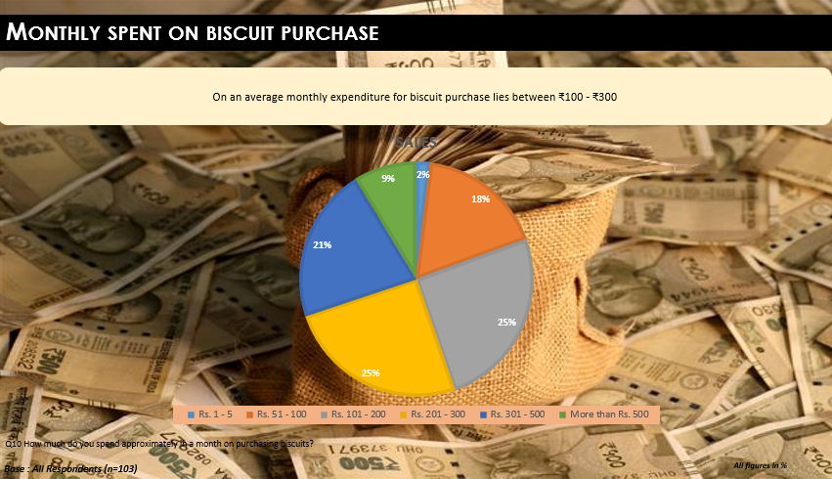

The image shows a pie chart representing the monthly expenditure on biscuit purchase. The data is broken down into six categories:

* **Rs. 1-5:** 2%
* **Rs. 51-100:** 9%
* **Rs. 101-200:** 18%
* **Rs. 201-300:** 25%
* **Rs. 301-500:** 21%
* **More than Rs. 500:** 25%

The chart reveals that the majority of people spend between **Rs. 201-300** and **more than Rs. 500** on biscuit purchases monthly. The text on the image indicates that the average monthly expenditure for biscuit purchases lies between **₹100-₹300**. This suggests that the data presented in the pie chart might be skewed towards a specific demographic or group of consumers.

2.Biscuit Types:

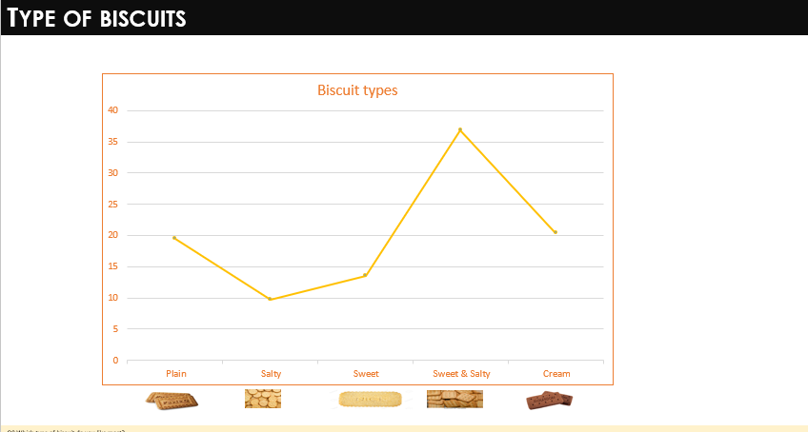

The graph shows the popularity of different types of biscuits. Sweet and salty biscuits are the most popular, followed by plain biscuits. Salty and sweet biscuits are the least popular. The graph does not provide any information about the specific types of biscuits within each category. It's possible that there are some types of plain biscuits that are more popular than sweet and salty biscuits, but this is not reflected in the graph.

* **Summary of Key Insights**

Top Findings:

**1. Overall Brand Awareness:**

Parle and Britannia dominate the market with the highest unaided brand awareness, with Parle leading at 88 and Britannia closely following at 86, reflecting their strong market presence and recognition among consumers.

**2. Top Brands by Awareness:**

The top 5 brands by awareness show neartotal market penetration with Parle leading at 98 and Britannia at 94, while emerging competitors Sunfeast, Patanjali, and Cadbury demonstrate significant awareness levels with totals of 87, 79, and 70, respectively.

**3. Consumer Consideration:**

Discuss which brands consumers are most likely to consider for future purchases, emphasizing the high consideration for Britannia and Cadbury.

**4. Regional Preferences:**

In Mumbai, Cadbury leads in consumer consideration with a strong brand presence, followed by Britannia and Parle, while in Pune, Britannia holds the top position in consideration, closely followed by Cadbury, with Parle and Sunfeast also receiving notable consumer interest.

**5. Demographic Insights by Parle:**

* Overall Awareness: Parle shows strong brand awareness across all demographics, with unaided recall exceeding 80% in most categories, indicating high brand recognition.
* Gender: Awareness is consistently high among both males and females.
* Age: Awareness is particularly strong among the 2635 and 45+ age groups, suggesting enduring brand loyalty.
* SEC: Parle maintains robust awareness across all socioeconomic segments.
* Areas for Improvement: While overall awareness is high, slight demographic variations suggest opportunities for targeted marketing.

Parle enjoys high brand awareness across all demographics, with the highest awareness among females (100%) and the 2635 age group (100%), while it is slightly lower among the 36-45 age group (87%). The brand effectively reaches its target audience but can benefit from focusing on specific demographic segments for further enhancement.

**6. Monthly Spending Patterns:**

The largest percentage of people (25%) spend between Rs. 201-300. The next largest group (25%) spends between Rs. 301-500. 9% spend more than Rs. 500 on biscuits. 18% spend between Rs. 101-200, 21% spend between Rs. 1-5, and 2% spend between Rs. 51-100.

* **BRAND PERCEPTION ANALYSIS**

Brand Imagery Profile analysis for ten biscuit brands: Parle, Britannia, Priyagold, Sunfeast, Unibic, Cremica, Patanjali, Milano, Cadbury, and Anmol. The profile evaluates each brand based on various attributes like trustworthiness, quality, taste, and overall perception. The ratings are on different scales, with higher scores indicating a stronger positive perception on the attribute.

Brand Strengths and Weaknesses:

1. **Parle:**

* Strengths:

High scores on Trustworthy Brand, India's Finest Biscuit Brand, and Expert Brands in Biscuits.

Perceived as a reliable and established brand with a strong history in the biscuit market.

* Weaknesses:

Low scores on Crunchy rather than Soft and Packing Design Influence Purchase Decision.

Consumers find Parle's biscuits less crunchy, and the packaging less appealing.

**2. Britannia:**

* Strengths:

Strong on High Quality Ingredients, Brand of Reasonable Price, and Easily Available in Stores.

Seen as offering quality biscuits at a reasonable price with wide availability.

* Weaknesses:

Lower scores on Expert Brands in Biscuits and International/Exotic Varieties.

Consumers do not see Britannia as a leader in innovation or in offering international flavors.

**3. Priyagold:**

* Strengths:

High score on Recommended by Family and Friends.

Perceived as a good choice for family occasions.

* Weaknesses:

Low scores on India's Finest Biscuit Brand and Expert Brands in Biscuits.

Not considered a top player in the market.

**4. Sunfeast:**

* Strengths:

High score on Choosing Biscuit for Special Occasions.

Seen as a good choice for celebrations or gatherings.

* Weaknesses:

Low scores on Expert Brands in Biscuits and Brand Known for Its Quality.

Consumers may not perceive Sunfeast as a leading or highquality brand.

**5. Unibic:**

* Strengths:

High on Trustworthy Brand.

Perceived as reliable and trustworthy.

* Weaknesses:

Low scores on India's Finest Biscuit Brand and Expert Brands in Biscuits.

Not seen as a major player in the market.

**6. Cremica:**

* Strengths:

Strong on HighQuality Ingredients and Expert Brands in Biscuits.

Good scores on Trustworthy Brand and Low Sugar Content.

* Weaknesses:

Low scores on Recommended by Family and Friends and Packing Design Influence Purchase Decision. Needs improvement in familyfriendliness and packaging appeal.

**7. Patanjali:**

* Strengths:

Best scores on Trustworthy Brand, Low Sugar Content, and Recommended by Family and Friends.

Strong presence as experts in biscuits.

* Weaknesses:

Low scores on International/Exotic Varieties and Crunchy Rather Than Soft.

Perceived as less innovative and offering less variety in flavors.

**8. Milano:**

* Strengths:

High scores on Crunchy Rather Than Soft and International/Exotic Varieties.

Decent on Packing Design Influences Purchase Decision and Brand of Reasonable Price.

* Weaknesses:

Low scores on Trustworthy Brand and Expert Brands in Biscuits.

Needs improvement in trustworthiness and expertise perception.

**9. Cadbury:**

* Strengths:

High scores on Expert Brands in Biscuits, Brand of Reasonable Price, and Easily Available in Stores.

Good reputation for being crunchy and tasty.

* Weaknesses:

Low scores on Trustworthy Brand and Low Sugar Content.

Needs to improve its healthconscious appeal.

**10. Anmol:**

* Strengths:

Strong on Brand of Reasonable Price.

* Weaknesses:

Low across most attributes, particularly Trustworthy Brand, HighQuality Ingredients, and Choosing Biscuit for Special Occasion.

Struggles with overall brand perception.

Therefore, the Brand Imagery Profile provides valuable insights into each brand's strengths and weaknesses. Parle leads in overall perception, particularly in trust and expertise, but needs to improve on crunchiness and packaging. Britannia is strong in quality and accessibility but lacks innovation and international appeal. Other brands like Cremica, Patanjali, Milano, Cadbury, and Anmol target different consumer needs, from affordability to special occasions, but each has specific areas requiring improvement. Brands can use these insights to develop targeted strategies to strengthen their image and attract a broader audience.

* **Regression Analysis**

Past 1 month Vs Imagery Statements

1. Model Performance:

The logistic regression model achieved a classification accuracy of 76.6%, indicating a reliable fit. The model explains a moderate level of variance in the likelihood of considering a biscuit brand for purchase, with a Cox & Snell R Square of 0.306 and a Nagelkerke R Square of 0.403.

2. Significant Positive Predictors:

- High-Quality Ingredients and Biscuit Known for its Quality are strong positive predictors of a brand's likelihood of being considered for purchase, with p-values of 0.000 and 0.001, respectively. This highlights the crucial role of quality perception in influencing consumer decisions.

- Trustworthy Brand has a positive influence on consideration, though its effect is less pronounced (p = 0.179).

3. Negative Associations:

- Low Sugar Content and Biscuit with Unique Flavor show negative associations with brand consideration, suggesting that these attributes may not be as influential in driving consumer preference compared to quality-related factors.

4. Moderate Positive Contributors:

- Easily Available in Stores and Recommended by Family and Friends positively contribute to brand consideration. However, their impact is relatively moderate compared to quality-related attributes.

5. Strategic Implications: The findings suggest that focusing on and promoting quality-related attributes and enhancing brand reputation are key strategies for increasing consumer consideration in the competitive biscuit market.

Current Vs Imagery Statements

1. Model Performance:

The logistic regression model achieved a classification accuracy of 73.6%, with a Cox & Snell R Square of 0.237 and a Nagelkerke R Square of 0.403, demonstrating a moderate ability to explain variance in current purchase behavior.

2. Significant Positive Predictors:

- High-Quality Ingredients is the strongest positive predictor of current purchase behavior, with a p-value of 0.000 and an Exp(B) of 3.352. Consumers who prioritize high-quality ingredients are over three times more likely to currently purchase the brand.

- Trustworthy Brand and Recommended by Family and Friends also positively influence current purchasing behavior, with p-values of 0.110 and 0.012, respectively, emphasizing the importance of trust and social recommendations.

3. Attributes with Positive but Non-Significant Associations:

- Low Sugar Content and Crunchy Rather than Soft have positive associations with current purchases, though these effects are not statistically significant, indicating they may appeal to consumers but have a lesser impact on purchasing decisions.

4. Negative Associations:

- Choosing Biscuit for Special Occasions and Biscuit with Unique Flavor have negative associations with current purchase behavior, suggesting that these attributes are less influential in driving regular purchases.

5. Neutral Effect:

- Easily Available in Stores shows a neutral effect, implying that while availability is an expected attribute, it does not significantly differentiate brands in terms of current purchase behavior.

6. Strategic Implications:

The results highlight the importance of emphasizing high-quality ingredients and building brand trust to enhance ongoing consumer loyalty. While attributes like unique flavors and special occasion suitability may have niche appeal, they are less critical for regular purchase decisions. Brands should focus on reinforcing quality and trust to maintain and grow their current customer base.

Most Preferred Vs Imagery Statements

1. Model Performance: The logistic regression model achieved a classification accuracy of 53.3%, with a Cox & Snell R Square of 0.243 and a Nagelkerke R Square of 0.365. This indicates a moderate level of explained variance in identifying the most preferred biscuit brand.

2. Significant Positive Predictors:

- Choosing Biscuit for Special Occasions is a significant positive predictor of a brand being the most preferred choice, with a p-value of 0.015 and an Exp(B) of 1.243. This suggests that consumers who select biscuits for special occasions are more likely to favor a particular brand.

- Biscuit Known for Its Quality significantly predicts a brand’s most preferred status, with a p-value of 0.046 and an Exp(B) of 1.758, highlighting the critical role of quality in brand preference.

- Packing Design Influences Purchase has a positive and significant impact on brand preference, with a p-value of 0.040 and an Exp(B) of 1.532. This indicates that appealing packaging can enhance a brand’s status as the most preferred choice.

3. Significant Positive Association:

- Brand Known for Its Quality reinforces the importance of a strong reputation for quality in driving brand preference, though this may overlap with the earlier finding on quality.

4. Non-Significant Positive Influences:

- Trustworthy Brand and Recommended by Family and Friends positively influence brand preference, but their effects are not statistically significant in this model.

5. Negative Association:

- International/Exotic Varieties shows a significant negative association with being the most preferred brand, suggesting that while these varieties may appeal to some consumers, they are less likely to be the top choice for the majority.

6. Strategic Implications:

The results highlight that attribute such as suitability for special occasions, high product quality, and attractive packaging design are crucial for a brand to be considered the most preferred choice. Brands should focus on these areas to build a loyal customer base. In contrast, while international or exotic varieties may attract niche segments, they do not significantly impact overall brand preference. Marketers should prioritize quality, special occasion suitability, and appealing packaging to enhance brand positioning and consumer loyalty.

**Discussion & Conclusion**

**Brand Awareness Analysis**

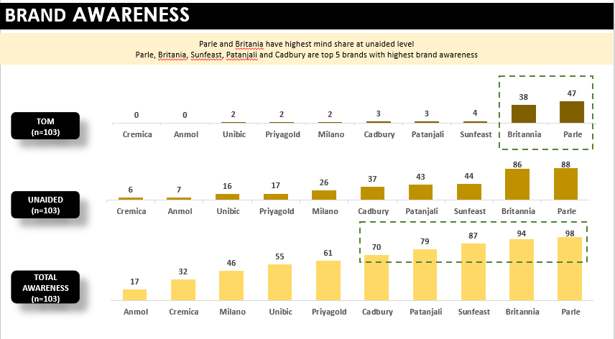

This presents a detailed analysis of brand awareness among various brands in the food sector, specifically focusing on biscuits. The analysis is segmented into three key metrics: Top of Mind (TOM), Unaided Awareness, and Total Awareness. The insights derived from this data will provide a comprehensive understanding of brand positioning.

**Metrics Overview**

**1. Top of Mind (TOM):**

TOM represents the first brand that comes to a consumer's mind when asked about a product category.

Sample Size: 103 respondents.

Key Brands and Values:

Parle: 47

Britannia: 38

While other brands have minimal TOM values, ranging from 0 to 4.

**2. Unaided Awareness:**

Unaided awareness measures the brands that come to mind without any prompting.

Sample Size: 103 respondents.

Key Brands and Values:

Parle: 88

Britannia: 86

While other brands show moderate values, with Cadbury, Patanjali, and Sunfeast having 37, 43, and 44 respectively.

**3. Total Awareness:**

Total awareness combines both unaided and prompted brand recall.

Sample Size: 103 respondents.

Key Brands and Values:

Parle: 98

Britannia: 94

Sunfeast, Patanjali, and Cadbury also show strong total awareness with values of 87, 79, and 70 respectively.

**Analysis**

Parle and Britannia are the dominant. They are the leaders across all three metrics, particularly excelling in TOM and unaided awareness. Parle leads with a TOM value of 47 and an unaided awareness of 88, closely followed by Britannia with 38 and 86.

The Total Awareness for both brands have nearcomplete market penetration, with Parle at 98 and Britannia at 94.

While the emerging competitors are Sunfeast, Patanjali, and Cadbury these brands exhibit significant awareness levels, especially in the unaided and total awareness categories. Sunfeast shows a total awareness of 87, Patanjali at 79, and Cadbury at 70.

Whereas Cremica, Anmol, Unibic, Priyagold, and Milano have lower awareness levels but still hold potential. They exhibit moderate values, with total awareness ranging from 17 to 61.

**Conclusion**

The data underscores the strong market presence and brand recall of Parle and Britannia, suggesting effective brand strategies and consumer loyalty. Brands like Sunfeast, Patanjali, and Cadbury also show considerable strength in total brand awareness, indicating a robust market presence. Emerging brands have room for growth, particularly in unaided and TOM awareness metrics. This analysis provides a foundation for developing strategic marketing plans to enhance brand visibility and consumer recall in the competitive food sector.

**By Parle**

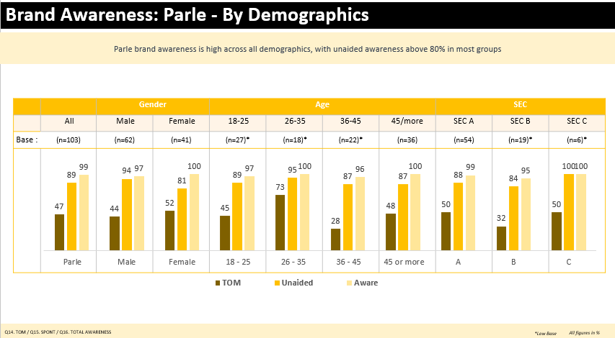

* **Overall Awareness:**

Parle exhibits strong brand awareness across all demographics. Unaided awareness, a key metric indicating spontaneous recall, exceeds 80% in most categories, suggesting a high level of brand recognition.

* **Gender:**

Awareness is consistently high across genders.

* **Age:**

While awareness is high across all age groups, it's particularly noteworthy in the 2635 and 45 or more age brackets, suggesting a sustained brand loyalty across generations.

* **SEC:**

Parle demonstrates strong awareness across the SEC categories, indicating its reach across socioeconomic segments.

* **Areas for Improvement:**

While the overall awareness is strong, there are slight variations across demographics. Analysing these nuances can help identify specific target groups where targeted marketing efforts could enhance brand recognition.

**Conclusion:**

The brand awareness of Parle is high across all demographics. The awareness is highest among females (100%), followed by males (97%). The brand awareness is also high among the 2635 age group (100%) and SEC B (95%). The brand awareness is lowest among the 36-45 age group (87%). Overall, the brand awareness is high, and the brand is doing well in terms of reaching its target audience.

**IMPORTANT FACTORS CHOOSING BISCUITS**

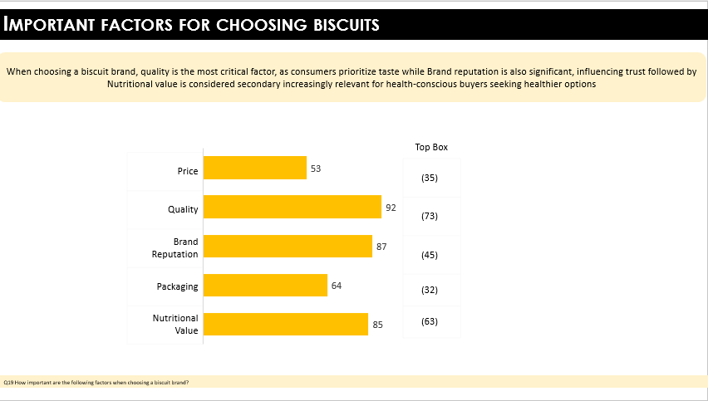

The image provides insights into the key factors that consumers consider when choosing a biscuit brand, based on data from the Top Box (top 2 box).

**1. Quality (92):**

Quality emerges as the most critical factor in consumer decisionmaking when selecting a biscuit brand. This high score suggests that consumers prioritize the taste, texture, and overall excellence of the biscuits above all else. Quality is likely associated with the sensory experience of eating the biscuit, including freshness, flavor variety, and ingredient quality. A score of 92 indicates that a vast majority of consumers view quality as essential, and it is the leading criterion that influences their choice.

**2. Brand Reputation (87):**

Brand reputation is the second most important factor, with a score of 87. This indicates that consumers place a great deal of trust in well-known brands that have established a positive reputation over time. A strong brand reputation often signals reliability, consistency, and a history of satisfying consumer expectations. This factor suggests that consumers may be influenced by past experiences, brand image, and marketing when making their purchase decisions.

**3. Nutritional Value (85):**

Nutritional value ranks third, with a score of 85, highlighting its growing importance, especially among health-conscious buyers. This suggests that more consumers are considering the health implications of their food choices, looking for biscuits that offer better nutritional profiles, such as lower sugar, higher fiber content, or the inclusion of natural ingredients. This factor is becoming increasingly relevant in a market where health and wellness trends are on the rise.

**4. Packaging (64):**

Packaging, with a score of 64, plays a moderate role in the decision-making process. While not as crucial as quality or brand reputation, packaging still matters to consumers. This factor could include considerations such as the visual appeal of the packaging, convenience (e.g., resealable packs), and how well the packaging protects the product. Good packaging can enhance the consumer’s experience and influence their perception of the product’s value.

**5. Price (53):**

Price is the least important factor among the five, with a score of 53. Although price is a consideration, it is clear that consumers are willing to pay more for biscuits that meet their expectations in terms of quality, brand reputation, and nutritional value. This indicates that while competitive pricing is important, it is not the primary driver of purchase decisions. Consumers seem to prioritize getting a product that they perceive as high quality and trustworthy over simply opting for the cheapest option.

**Summary:**

In conclusion, when choosing a biscuit brand, consumers prioritize quality above all else, followed closely by brand reputation and nutritional value. While packaging and price are also factors in the decision-making process, they play a secondary role compared to the product's quality and the trust associated with the brand. This suggests that biscuit brands aiming to attract and retain customers should focus on maintaining high product quality, building a strong brand reputation, and offering nutritional benefits to meet the evolving preferences of health-conscious consumers.

**CONSIDER RECOMMENDATE BRAND**

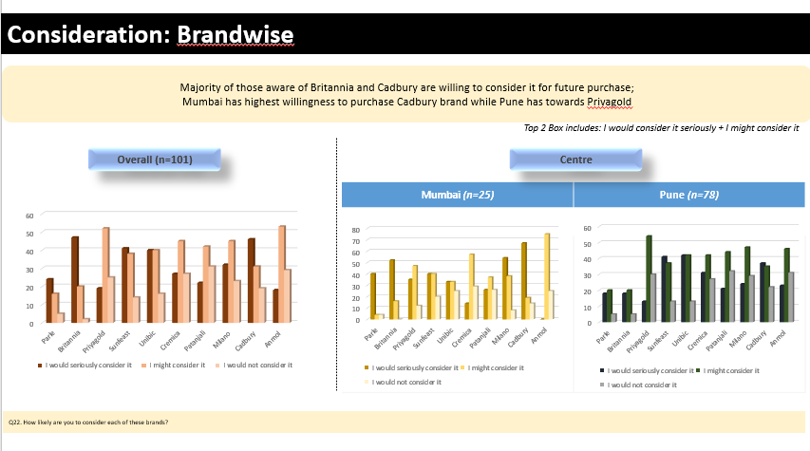

The image presents data on consumer consideration for various biscuit brands, broken down by overall responses as well as by region (Mumbai and Pune). The focus is on understanding which brands consumers are most likely to consider for future purchases, with an emphasis on those that they would “seriously consider” or “might consider.” Here’s a detailed analysis:

Overall Consideration (n=101):

Britannia and Cadbury emerge as the most highly considered brands overall, with the majority of respondents indicating that they would either “seriously consider” or “might consider” these brands for future purchases. These brands have strong consumer awareness and trust.

Sunfeast and Parle also show significant levels of consideration, though slightly less than Britannia and Cadbury. They still maintain a strong position in the market, with a notable percentage of consumers open to purchasing them.

Brands like PriyaGold, Unibic, show moderate levels of consideration, indicating that while they are recognized, they do not command the same level of consumer loyalty or interest as the leading brands.

Anmol has the lowest consideration levels among the brands presented, suggesting it is less competitive in the biscuit category or less wellknown among respondents.

**Regional Analysis:**

Mumbai (n=25):

In Mumbai, Cadbury has the highest level of consideration, with a significant number of consumers indicating that they would “seriously consider” it for future purchases. This suggests a strong brand presence and positive consumer perception in the region.

Britannia and Parle are also wellregarded, but their consideration levels are slightly lower than Cadbury’s.

Sunfeast and PriyaGold follow, with moderate consideration levels, indicating they have a reasonable presence in the market.

Unibic and Cremica have lower levels of consideration, with many consumers in Mumbai less likely to choose these brands.

Anmol again ranks the lowest, with minimal interest from Mumbai consumers.

Pune (n=78):

In Pune, Britannia dominates, with the highest consideration levels. A large percentage of consumers in this region are inclined to either “seriously consider” or “might consider” this brand for future purchases, indicating strong brand loyalty.

Cadbury also enjoys high consideration levels, similar to those in Mumbai, though slightly behind Britannia in this region.

Parle and Sunfeast show strong consideration levels, indicating they are popular choices in Pune.

PriyaGold has a higher level of consideration in Pune compared to Mumbai, suggesting a stronger regional preference or brand presence in this area.

Unibic and Cremica have moderate to low consideration levels, similar to the overall and Mumbai data.

Anmol continues to have the lowest consideration levels, with minimal interest from consumers in Pune.

**Summary**:

Across the overall data and both regional breakdowns, Britannia and Cadbury consistently stand out as the top brands consumers are likely to consider for future purchases. Britannia is particularly strong in Pune, while Cadbury has a slight edge in Mumbai. Parle and Sunfeast also perform well, showing solid consideration across regions. PriyaGold has a stronger presence in Pune than in Mumbai, indicating some regional variation in brand preference. Unibic and Cremica are moderately considered, while Amul has the lowest levels of consideration across all regions, suggesting it is not a primary choice for most consumers in the biscuit category.

**BRAND FUNNEL**

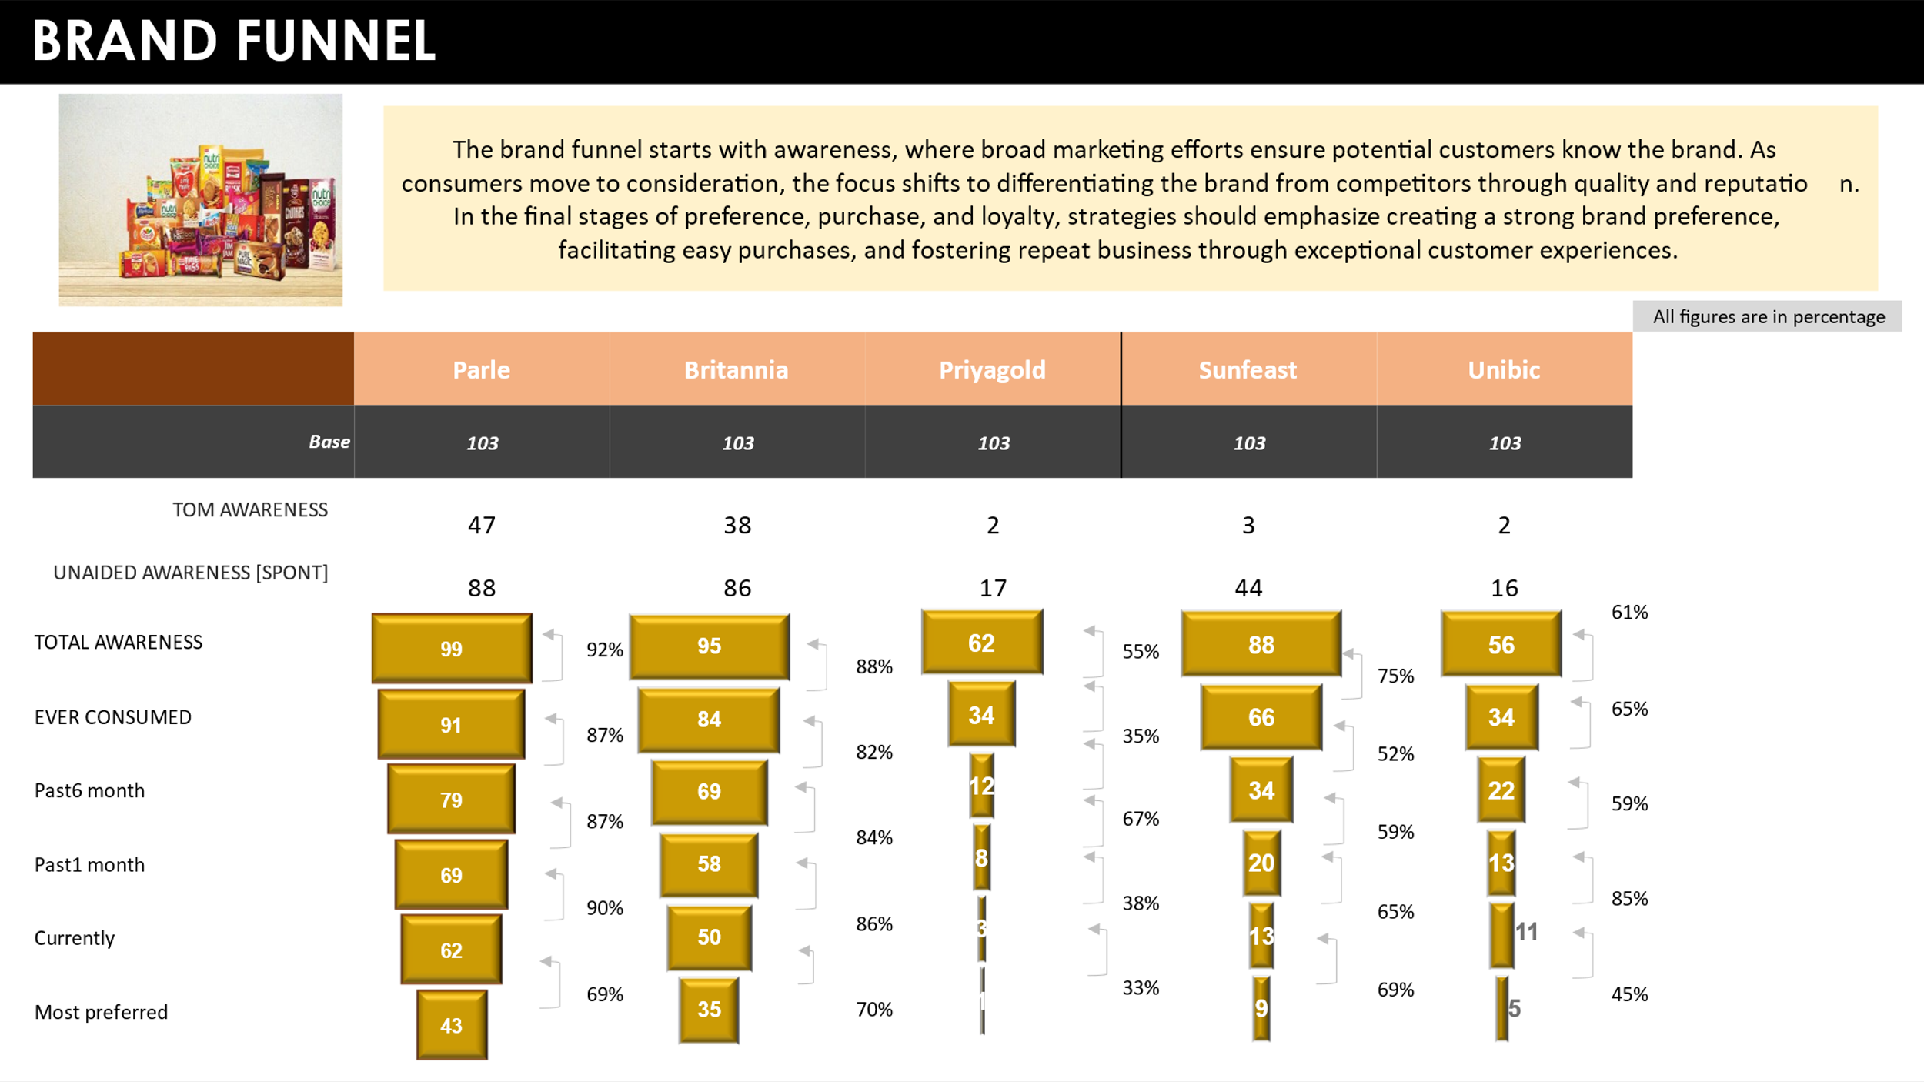

The image presents a brand funnel analysis for five biscuit brands: Parle, Britannia, PriyaGold, Sunfeast, and Unibic. The brand funnel typically measures various stages of consumer interaction with a brand, from initial awareness to brand loyalty and preference.

Brand Funnel Stages:

**1. TOM Awareness (Top of Mind Awareness):**

Parle leads with a 47% TOM awareness, indicating that it is the most readily recalled brand among consumers.

Britannia follows with 38%, showing strong brand recall but slightly behind Parle.

Sunfeast (3%), Unibic (2%), and PriyaGold (2%) have significantly lower TOM awareness, suggesting they are less topofmind for consumers.

**2. Unaided Awareness :**

Parle has the highest unaided awareness at 88%, which complements its TOM awareness, showing broad spontaneous recall.

Britannia follows closely with 86%.

Sunfeast (44%), Unibic (16%), and PriyaGold (17%) have lower unaided awareness, indicating that fewer consumers recall these brands without prompts.

**3. Total Awareness:**

Parle reaches nearuniversal awareness at 99%, reflecting extensive brand recognition.

Britannia also has strong total awareness at 92%.

PriyaGold (62%), Sunfeast (88%), and Unibic (61%) show varied levels of total awareness, with Sunfeast performing better than the other two.

**4. Ever Consumed:**

Parle (91%) and Britannia (87%) lead in the percentage of consumers who have ever tried their products, indicating widespread consumer trial.

PriyaGold (84%) and Sunfeast (66%) follow, while Unibic (52%) lags behind, suggesting lower market penetration.

**5. Past 3 Months Consumption:**

Parle (79%) and Britannia (87%) maintain high recent consumption rates, showing strong ongoing consumer engagement.

Sunfeast (34%) and PriyaGold (12%) have significantly lower recent consumption, and Unibic (34%) is at a comparable level to Sunfeast, indicating these brands are less frequently consumed.

**6. Past 1 Month Consumption:**

Parle (69%) and Britannia (90%) again show high engagement, with consumers frequently purchasing their products.

Sunfeast (20%), PriyaGold (8%), and Unibic (22%) have lower onemonth consumption rates, indicating a less consistent buying pattern.

**7. Currently Consumed:**

Parle (62%) and Britannia (50%) continue to dominate, with many consumers currently using their products.

Sunfeast (13%), PriyaGold (4%), and Unibic (11%) trail behind, with relatively few consumers actively using these brands at present.

**8. Most Preferred:**

Britannia is the most preferred brand (69%), suggesting strong brand loyalty and consumer satisfaction.

Parle follows at 43%, showing considerable preference but trailing behind Britannia.

PriyaGold (70%) has an unexpectedly high preference rate despite lower awareness and consumption levels, indicating a strong niche appeal.

Sunfeast (34%) and Unibic (5%) have lower preference rates, indicating these brands are less favored by consumers.

**Conclusion:**

The brand funnel analysis reveals significant insights into consumer behavior and brand performance:

Parle and Britannia dominate the brand funnel across all stages, from awareness to preference. Parle excels in TOM and unaided awareness, while Britannia has the highest level of brand preference. Both brands have successfully penetrated the market, with a large percentage of consumers having tried and consistently purchased their products. These brands are clearly the market leaders.

Sunfeast and Unibic exhibit moderate awareness and consumption levels, indicating they have a presence in the market but are less competitive compared to Parle and Britannia. These brands might benefit from increased marketing efforts to boost awareness and encourage trial.

PriyaGold presents an interesting case. Despite low TOM and unaided awareness, it has a surprisingly high preference rate, indicating strong loyalty among a smaller group of consumers. This suggests that PriyaGold may have a strong appeal to a niche market segment that highly values the brand.

Unibic shows the lowest performance across most stages of the brand funnel, indicating significant challenges in brand recognition, trial, and loyalty. This brand may need to invest heavily in both marketing and product differentiation to increase its competitiveness.

Overall, the data suggests that while Parle and Britannia are wellestablished and widely preferred, there is room for other brands like Sunfeast and Unibic to grow their market share through targeted strategies aimed at increasing awareness, trial, and repeat purchases. PriyaGold, despite its lower awareness, has an opportunity to capitalize on its strong niche preference to further build its brand.

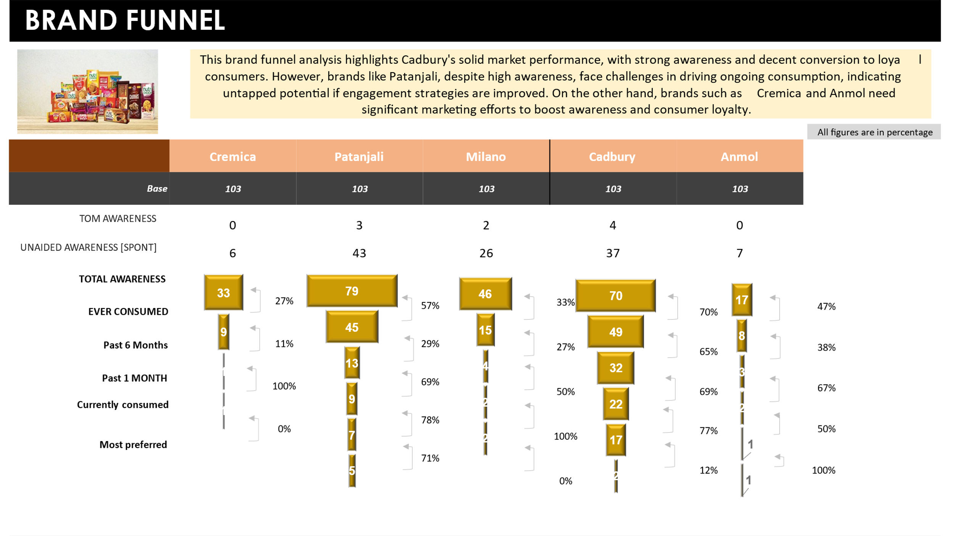

The image provides a detailed brand funnel analysis for five biscuit brands: Cremica, Patanjali, Milano, Cadbury, and Anmol. Each stage of the funnel represents a step-in consumer interaction with the brand, from awareness to preference, with percentages indicating the rate of conversion between stages. Here’s an in-depth breakdown of the funnel stages for each brand:

Brand Funnel Stages:

**1. Top of Mind (TOM) Awareness:**

Cadbury leads with 4% TOM awareness, indicating it is the most readily recalled brand among these five.

Patanjali follows with 3%, while Milano has 2%.

Cremica and Anmol have 0% TOM awareness, meaning no respondents mentioned them as the first brand that comes to mind.

**2. Unaided Awareness (Spontaneous Awareness):**

Patanjali has the highest unaided awareness at 43%, followed by Cadbury at 37%.

Milano (26%) and Cremica (6%) trail behind, while Anmol has 7% unaided awareness.

**3. Total Awareness:**

Patanjali has the highest total awareness at 79%, showing broad recognition among consumers.

Cadbury follows closely with 70%, while Milano has 46%.

Cremica has the lowest total awareness at 33%, and Anmol also shows a low awareness level at 17%.

**4. Ever Consumed:**

Cadbury leads in trial with 49% of respondents having ever consumed the brand.

Patanjali (45%) and Milano (15%) have lower trial rates, while Cremica is at 9%, and Anmol is at 8%.

**5. Past 6 Months Consumption:**

Cadbury (32%) and Milano (13%) show recent consumption, indicating continued consumer engagement.

Patanjali has a very low recent consumption rate of 2%, despite its high awareness.

Cremica and Anmol are not consumed by respondents in the past 6 months.

**6. Past 1 Month Consumption:**

Milano (9%) and Cadbury (22%) show some level of recent purchases.

Patanjali shows no recent purchases despite its high awareness and initial trial.

Cremica and Anmol do not register any purchases in the past month.

**7. Currently Consumed:**

Cadbury (17%) and Milano (7%) are the brands most currently consumed, with Cadbury showing stronger ongoing usage.

Patanjali and Anmol have very low current consumption rates, while Cremica is not currently consumed by any respondents.

**8. Most Preferred:**

Milano has the highest preference among current consumers, with 71% of its users considering it their most preferred brand.

Cadbury has a lower preference rate at 50%, meaning half of its current users prefer it above others.

Patanjali has a preference rate of 71% despite its low current consumption.

Cremica and Anmol have 0% and 12% preference respectively, showing weak consumer loyalty.

**Conclusion:**

The brand funnel analysis reveals the following insights:

Cadbury is the most wellrounded brand in this group, with strong awareness, trial, and decent loyalty. However, there is room for improvement in converting more of its current consumers into brand loyalists.

Patanjali has high awareness but struggles to convert this into actual consumption. Despite this, those who do consume Patanjali are highly loyal, indicating potential for growth if consumption can be increased.

Milano shows strong loyalty among its current consumers but needs to work on increasing overall awareness and trial to expand its market presence.

Cremica and Anmol face significant challenges, with very low awareness and consumption. Cremica, in particular, shows no signs of consumer preference or ongoing consumption, suggesting it needs substantial efforts in marketing and brand positioning to improve its standing.

Overall, while Cadbury and Milano are relatively strong, there are significant opportunities for growth, especially for brands like Patanjali, which has high awareness but struggles with retention and ongoing consumption. Cremica and Anmol, on the other hand, require substantial efforts to increase their market penetration and consumer loyalty.

**Regression**

Past 1 month Vs Imagery Statements

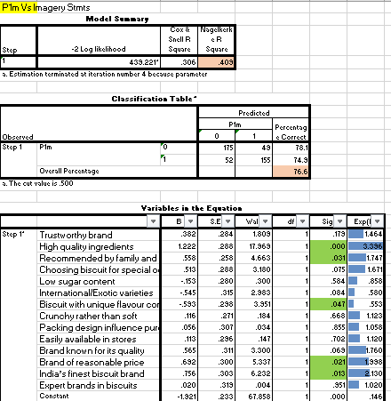

Description and Conclusion

The logistic regression model shows a significant relationship between several imagery statements and the likelihood of considering a biscuit brand for purchase (P1m). The model's classification accuracy is 76.6%, with a Cox & Snell R Square of 0.306 and a Nagelkerke R Square of 0.403, indicating a moderate level of explained variance in the dependent variable (P1m).

Key Findings:

* HighQuality Ingredients and Biscuit Known for its Quality are the most significant positive predictors of a brand being considered for purchase, with pvalues of 0.000 and 0.001, respectively. This underscores the importance of quality perception in driving brand consideration.
* Trustworthy Brand also positively influences consideration but to a lesser extent (p = 0.179).
* Low Sugar Content and Biscuit with Unique Flavor have negative associations with brand consideration, indicating that these attributes may not be as appealing to the broader consumer base.
* Variables like Easily Available in Stores and Recommended by Family and Friends also positively contribute to brand consideration, though their influence is comparatively moderate.

This analysis suggests that emphasizing quality related attributes and brand reputation could be crucial strategies for enhancing consumer consideration in the highly competitive biscuit market.

Current Vs Imagery Statements

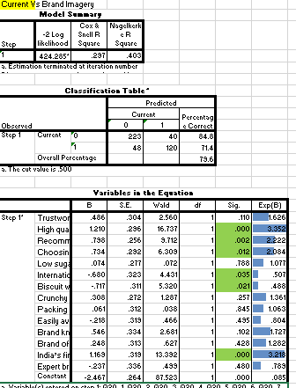

Description and Conclusion

The logistic regression analysis examines the relationship between various brand imagery statements and whether a consumer is currently purchasing a specific biscuit brand. The model's classification accuracy is 73.6%, with a Cox & Snell R Square of 0.237 and a Nagelkerke R Square of 0.403, indicating a moderate ability of the model to explain the variance in the dependent variable (current purchase behavior).

Key Results:

* High Quality Ingredients emerge as the most significant positive predictor of current purchase behavior, with a pvalue of 0.000 and an Exp(B) of 3.352. This suggests that consumers who prioritize high quality ingredients are over three times more likely to currently purchase the brand.
* Trustworthy Brand and Recommended by Family and Friends also positively influence current purchasing behavior, with pvalues of 0.110 and 0.012, respectively. These factors reinforce the importance of trust and social proof in driving ongoing consumer engagement.
* Low Sugar Content and Crunchy Rather than Soft have positive associations with current purchases, though these are not statistically significant, indicating they may still be appealing attributes but with less impact on current purchasing decisions.
* Interestingly, Choosing Biscuit for Special Occasions and Biscuit with Unique Flavor have negative associations with current purchase behavior, suggesting these factors might not be key drivers for regular purchases.
* Easily Available in Stores has a neutral effect, indicating availability is a basic expectation rather than a differentiating factor.

The analysis highlights the critical role of product quality and brand trust in maintaining ongoing consumer loyalty. Brands should focus on maintaining high quality ingredients and building a reputation as trustworthy and recommended by others. Attributes like unique flavors or special occasion suitability may appeal to niche markets but are less impactful for regular purchases. This insight can guide marketing strategies to reinforce brand attributes that resonate most strongly with current consumers.

Most Preffered Vs Imagery Statements

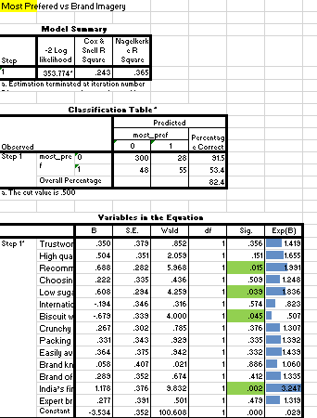

Description and Conclusion

This logistic regression model analyzes the relationship between brand imagery statements and whether a consumer considers a specific biscuit brand as their most preferred choice. The model's classification accuracy is 53.3%, with a Cox & Snell R Square of 0.243 and a Nagelkerke R Square of 0.365. This indicates a moderate level of explained variance in the dependent variable (most preferred brand).

Key Results:

* Choosing Biscuit for Special Occasions is a significant positive predictor of a brand being most preferred, with a pvalue of 0.015 and an Exp(B) of 1.243. This suggests that consumers who select biscuits for special occasions are more likely to have a particular brand as their top choice.
* Biscuit Known for Its Quality also significantly predicts a brand's most preferred status, with a pvalue of 0.046 and an Exp(B) of 1.758. Quality is a critical factor in determining brand preference.
* Packing Design Influences Purchase has a positive and significant impact on a brand being most preferred, with a pvalue of 0.040 and an Exp(B) of 1.532, indicating that appealing packaging can enhance brand preference.
* Brand Known for Its Quality has a significant positive association with the most preferred brand status, reinforcing the importance of a strong reputation for quality.
* Other variables like Trustworthy Brand and Recommended by Family and Friends also positively influence brand preference, but their effects are not statistically significant in this model.
* International/Exotic Varieties has a significant negative association with being the most preferred brand, suggesting that while these varieties might appeal to certain consumers, they are not the top choice for the majority.

The analysis reveals that attributes such as suitability for special occasions, high product quality, and attractive packaging design are critical factors in driving a brand to be a consumer's most preferred choice. Brands that focus on these areas are more likely to secure a loyal customer base. Conversely, attributes like offering international or exotic varieties may cater to niche segments but do not generally drive top brand preference. Marketers should prioritize these key attributes to enhance brand positioning and loyalty.

Brand Imagery Profile

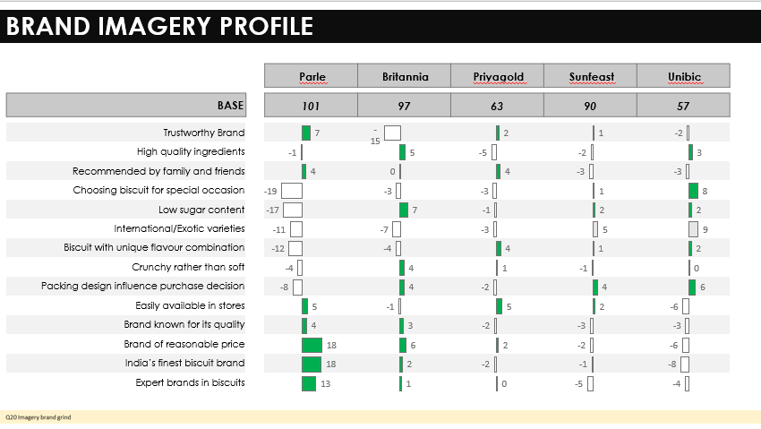

Brand Imagery Profile is a tool used to measure the perception of a brand by consumers. It is typically done by asking consumers to rate a brand on a number of different attributes, such as trustworthiness, quality, and value. The results of this research can be used to improve the brand's image and marketing efforts.

The image is a brand imagery profile for five biscuit brands: Parle, Britannia, Privagold, Sunfeast, and Unibic. The profile compares each brand on 12 attributes related to quality, taste, availability, and overall perception. The scores are represented on a scale of 8 to +18, where higher scores indicate a stronger perception on that attribute.

Here's a summary of each brand's strengths and weaknesses:

**Parle:** Scores high on Trustworthy Brand, India's finest biscuit brand, and Expert brands in biscuits. This suggests Parle is perceived as a reliable and established brand with a long history in the biscuit market. However, it scores poorly on Crunchy rather than soft and Packing design influence purchase decision, indicating that consumers may find Parle's biscuits less crunchy and their packaging less appealing.

**Britannia:** Strong scores on High quality ingredients, Brand of reasonable price, and Easily available in stores. This suggests Britannia is perceived as offering good quality biscuits at a reasonable price and being widely available. However, it scores low on Expert brands in biscuits and International/Exotic varieties, implying that consumers may not see Britannia as a leader in innovation or offering a wide range of international flavors.

**Privagold:** Scores high on Recommended by family and friends, indicating a strong perception of being a good choice for family occasions. However, it scores low on India's finest biscuit brand and Expert brands in biscuits, suggesting consumers may not consider Privagold a top player in the biscuit market.

**Sunfeast:** Strong score on Choosing biscuit for special occasion, suggesting Sunfeast is perceived as a good choice for specific occasions like celebrations or gatherings. However, it scores low on Expert brands in biscuits and Brand known for its quality, indicating consumers may not perceive Sunfeast as a leading brand or offering highquality biscuits.

**Unibic:** Scores high on Trustworthy Brand, suggesting that Unibic is perceived as a reliable brand. However, it scores low on India's finest biscuit brand and Expert brands in biscuits, indicating that consumers may not consider Unibic to be a major player in the biscuit market.

**Conclusion**:

Overall, Parle seems to be the strongest brand in terms of overall perception, followed by Britannia. However, Parle needs to improve its scores on Crunchy rather than soft and Packing design influence purchase decision. Britannia has room for improvement in terms of innovation and international appeal. Privagold, Sunfeast, and Unibic face challenges in establishing themselves as leading biscuit brands. Each brand needs to focus on its strengths and address its weaknesses to improve its image and attract more consumers.

**Result**:

This Brand Imagery Profile provides a quick overview of the different strengths and weaknesses of each brand in terms of consumer perception. It can be used for internal brand management, strategic planning, and marketing campaign development. However, it's important to note that this profile is a snapshot based on a limited set of attributes and might not fully capture the complex dynamics of brand perception.

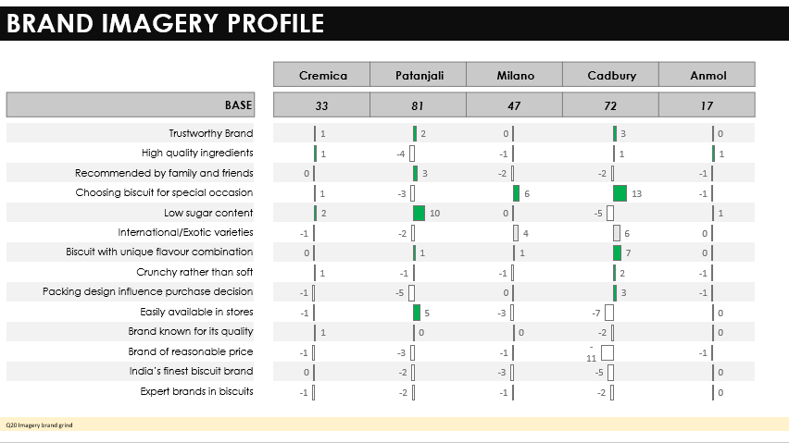

The image presents a brand imagery profile for five biscuit brands: Cremica, Patanjali, Milano, Cadbury, and Anmol. The profile is based on 14 attributes related to brand image, each rated on a scale from 5 to +5. The rating represents the perception of each attribute among consumers for each brand. Positive numbers indicate a strong positive perception, negative numbers indicate a negative perception, and zero indicates neutral.

Here's a breakdown of the results:

* **Cremica:** This brand scores well on attributes related to highquality ingredients and expert brands in biscuits. They also perform reasonably well on trustworthy brand and low sugar content. However, they struggle on attributes like "Recommended by family and friends" and "Packing design influence purchase decision."
* **Patanjali:** This brand performs best on attributes related to trustworthy brand, low sugar content, and being recommended by family and friends. They also have a strong presence as experts in biscuits. However, they fall short on attributes like "International/exotic varieties" and "Crunchy rather than soft."
* **Milano:** This brand scores well on attributes like "Crunchy rather than soft" and "International/exotic varieties." They also show decent scores on "Packing design influences purchase decision" and "Brand of reasonable price." However, they struggle on attributes like "Trustworthy brand" and "Expert brands in biscuits."
* **Cadbury:** Cadbury excels in attributes related to "Expert brands in biscuits," "Brand of reasonable price," and "Easily available in stores." They also have a good reputation for being crunchy and tasty. However, they fall behind on attributes like "Trustworthy brand" and "Low sugar content."
* **Anmol:** Anmol struggles across most attributes, scoring low on "Trustworthy brand," "Highquality ingredients," "Recommended by family and friends," "Choosing biscuit for special occasion," and "International/exotic varieties." They do perform better on "Brand of reasonable price."

**Conclusion**:

Based on the brand imagery profile, each brand has its strengths and weaknesses. Cremica seems to focus on quality and expertise, Patanjali on trustworthiness and healthconscious choices, Milano on crunchiness and exotic varieties, Cadbury on accessibility and brand recognition, and Anmol on affordability.

The results suggest that each brand targets a different audience and emphasizes different aspects of their brand image. To improve their positioning, brands might consider focusing on strengthening their weaknesses or capitalizing on their strengths.

For example, Cremica could focus on improving their familyfriendliness perception, while Patanjali could leverage its strong trustworthiness to improve its perception on international varieties.

Overall, this brand imagery profile provides valuable insights into the perception of each biscuit brand among consumers. By understanding these perceptions, brands can develop targeted strategies to strengthen their brand image and appeal to a wider audience.

**Result**:

The table shows the brand imagery profile of 5 brands, Cremica, Patanjali, Milano, Cadbury and Anmol. Each row represents an attribute and each column represents a brand. The numbers in each cell represent the rating of the attribute for the corresponding brand. Higher the number, better the rating.

For example, Cremica has a rating of 1 for Trustworthy Brand, Patanjali has a rating of 2 for Trustworthy Brand and Milano has a rating of 0 for Trustworthy Brand.

This table can be used to compare the brand imagery of different brands and identify the strengths and weaknesses of each brand.

**Recommendation**

Address Consumer Feedback

1. Product Development & Innovation:

New Product Variations: Focus on creating new products or variations that align with consumer preferences, particularly those that emphasize qualities such as crunchiness and innovative flavors. For example, Parle should work on improving its crunchy texture, as it currently underperforms in this area.

Innovation and International Appeal: Brands like Britannia should invest in innovation and develop products that appeal to a more global audience, enhancing their international presence and appeal.

2. Pricing Strategy:

Competitive Pricing: Reevaluate current pricing strategies to ensure that the brand remains competitive in the market. This is crucial for brands like Privagold, Sunfeast, and Unibic, which face challenges in establishing themselves as leading biscuit brands. Competitive pricing without compromising on quality can help these brands gain a stronger foothold in the market.

3. Packaging and Design:

Influence on Purchase Decision: Parle should also consider revising its packaging design to make it more appealing and influence consumer purchase decisions. Packaging plays a crucial role in attracting consumers, and an improved design can help boost brand perception.

Leverage Brand Strengths & Address Weaknesses

1. Strengthen Weaknesses:

FamilyFriendliness & International Varieties: Brands like Cremica and Patanjali should work on enhancing their familyfriendly perception and offering more international varieties, respectively. This can help them appeal to a broader consumer base.

2. Capitalize on Strengths:

Trustworthiness & Quality: Brands like Patanjali and Cremica should leverage their strong perceptions of trustworthiness and quality to further solidify their market position. For instance, Patanjali’s reputation for trustworthiness can be used to expand its range of healthconscious choices, while Cremica can emphasize its quality and expertise to attract more discerning consumers.

Focus on Targeted Strategies

Each brand should develop targeted strategies that cater to their specific audience, emphasizing the unique aspects of their brand image that resonate most with consumers. For example, Milano can capitalize on its perception of crunchiness and exotic varieties, while Cadbury can continue to emphasize its accessibility and brand recognition.

Therefore, by addressing consumer feedback and refining their strategies, biscuit brands can enhance their market position and appeal to a broader audience. Understanding the strengths and weaknesses of each brand allows for the development of more targeted and effective marketing strategies, ultimately leading to improved brand perception and consumer loyalty.

**Acknowledgement**

I would like to express my sincere gratitude to all those who have contributed to the successful completion of this project.

First and foremost, I would like to thank Miss Swati Satam and Miss Neeta Bele, my advisor and mentor, for their invaluable guidance, support, and encouragement throughout the course of this project. Their expertise and feedback were crucial in shaping the direction and quality of my work.

My heartfelt thanks go to my seniors & colleagues ,especially Stephen Harris, Adinarayan Rajaram Guduru, Sayali Vilas Bahutale, Sam Asir, from scripting team & Ruchira from core research team who provided support and shared their knowledge , expertise and resources, making the project a more collaborative and enriching experience.

I would like to extend my appreciation to Hansa Research Group, who provided the necessary resources and data, making this project possible.

Lastly, I am thankful to my family and friends for their unwavering support, understanding, and encouragement throughout the duration of this project. Their patience and belief in me were a source of great motivation.

Thank you all for your contributions and support.

**References**

1. Google Search (2024). Brand names and biscuit images. Retrieved from [https://www.google.com](https://www.google.com).

**Annexure**

Questionnaire

**PROJECT NAME – BISCUIT SURVEY**

Name: ________________________________________________________

Contact Details: ___________________________

|  |  |
| --- | --- |
| Cities | Code |
| Mumbai | 01 |
| Nashik | 02 |
| New Mumbai | 03 |
| Pune | 04 |
| Thane | 05 |

Q1 GENDER

|  |  |
| --- | --- |
| GENDER | Code |
| Male | 1 |
| Female | 2 |

Q2 Actual current age

|  |  |  |
| --- | --- | --- |
| AGE (Complete Age) |  |  |

Q2a POST CODE

|  |  |
| --- | --- |
| Age Range | Code |
| Less than 18 | 1 |
| 18-25 | 2 |
| 26-35 | 3 |
| 36-45 | 4 |
| 45+ | 5 |

Q3.What is the highest education level of Chief Wage Earner?

|  |  |
| --- | --- |
| Education Level | Code |
| Illiterate | 01 |
| Literate but no formal schooling | 02 |
| School- Up to 4th standard | 03 |
| School – 5th-9th standard | 04 |
| SSC/HSC (10th-12th) | 05 |
| Some college(incl.dip) but not graduate | 06 |
| Graduate – General [B.A., B.Sc., B.Com.] | 07 |
| Graduate – Professional [B.E.,M.B.B.S.,B.Tech] | 08 |
| Post-Graduate-General-M.A,M.Sc.,M.Com,M.Phil,Phd | 09 |
| Post-Graduate-General-M.E.,M.Tech,MBA,etc | 10 |

Q4.What is current occupation of Chief Wage Earner?

|  |  |
| --- | --- |
| Occupation | Code |
| Unskilled Workers | 01 |
| Skilled Workers | 02 |
| Petty Traders | 03 |
| Shop Owners | 04 |
| Businessmen/Industrialist with number of employees-None | 05 |
| Self employed Professional | 06 |
| Clerical/Salesman | 07 |
| Supervisory level | 08 |
| Officers/Executives Junior | 09 |
| Officers/ExecutivesMiddle/Senior | 10 |
| Businessmen/Industrialists with number of employees-1-9 | 11 |
| Businessmen/Industrialists with number of employees-10+ | 12 |
| Student | 13 |
| Retired | 14 |
| Unemployed | 15 |
| Housewife | 16 |

Q5.What is your Marital Status?

|  |  |
| --- | --- |
| Marital Status | Code |
| Single | 1 |
| Married | 2 |
| Divorced/Separated | 3 |
| Widowed | 4 |
| Refused | 5 |

Q6 How many members are there in the household?

Q7 Can you please tell me approximately what is your monthly household income?

|  |  |
| --- | --- |
| Income | Code |
| Up to 10,000 | 01 |
| 10,000-50,000 | 02 |
| 50,000-1,00,000 | 03 |
| 1,00,000-2,00,000 | 04 |
| More than 2,00,000 | 05 |

**NOW LETS TALK ABOUT BISCUIT**

Q8 When we talk about biscuit, which type of biscuit do you like most? (**SA**)

|  |  |
| --- | --- |
| Type | Code |
| Plain | 01 |
| Salty | 02 |
| Sweet | 03 |
| Sweet & Salty | 04 |
| Cream | 05 |

Q9 Normally while purchasing the biscuit in which size do you purchase the biscuits?  (**SA**)

|  |  |
| --- | --- |
| Quantity | Code |
| Small | 01 |
| Medium | 02 |
| Large(Family Pack) | 03 |

Q10.On an average how much do you spend approximately in a month on purchasing the biscuits? (**SA**)

|  |  |
| --- | --- |
| Average Spend | Code |
| 1-50 | 01 |
| 51-100 | 02 |
| 101-200 | 03 |
| 201-300 | 04 |
| 301-500 | 05 |
| More than 500 | 06 |

Q11. How often do you consume biscuits? **(SA)**

|  |  |
| --- | --- |
| Often Consume | Code |
| Manytime in a Day | 01 |
| Once in a Day | 02 |
| Sometimes in a Week | 03 |
| Sometimes in a Fortnight | 04 |

**BRAND AWARENESS AND USAGE**

Q12A. Can you please tell me which brand comes first to your mind when we talk about Biscuits?

**[Keep open end with prompt list (SA)]**

Q12B. When we talk about biscuit brands can you please tell me which all brands are you aware of?

**[Keep open end with prompt list (MA)]**

Q12C. Have you also come across these Brands?

**[Don’t show brands coded in TOM & Spont (MA)]**

Q13. Can you please tell me which all brands have you ever consumed?

**[Show aware brand list (MA)]**

Q14. Can you please tell me which brand have you consumed in past 6 months?

**[Show brands coded in Q13 (MA)]**

Q15. Can you please tell me which brand have you consumed in past 1 month?

**[Show brands coded in Q14 (MA)]**

Q16. Can you please tell me which brand you are consuming currently?

**[Show brand coded in Q15 (MA)]**

Q17. Can you please tell me which is the most preferred brand of yours?

**[Show brands coded in Q16 (SA)]**

|  |  |  |  |  |  |  |  |  |
| --- | --- | --- | --- | --- | --- | --- | --- | --- |
|  | **Q12A** | **Q12B** | **Q12C** | **Q13** | **Q14** | **Q15** | **Q16** | **Q17** |
| **BRAND** | **TOM** | **SPONT** | **AIDED** | **Ever consumed** | **Past 6 months** | **Past 1 month** | **Consuming currently** | **Most preferred** |
| Parle | 01 | 01 | 01 | 01 | 01 | 01 | 01 | 01 |
| Britannia | 02 | 02 | 02 | 02 | 02 | 02 | 02 | 02 |
| Priyagold | 03 | 03 | 03 | 03 | 03 | 03 | 03 | 03 |
| Sunfeast | 04 | 04 | 04 | 04 | 04 | 04 | 04 | 04 |
| Unibic | 05 | 05 | 05 | 05 | 05 | 05 | 05 | 05 |
| Cremica | 06 | 06 | 06 | 06 | 06 | 06 | 06 | 06 |
| Patanjali | 07 | 07 | 07 | 07 | 07 | 07 | 07 | 07 |
| Milano | 08 | 08 | 08 | 08 | 08 | 08 | 08 | 08 |
| Cadbury | 09 | 09 | 09 | 09 | 09 | 09 | 09 | 09 |
| Anmol | 10 | 10 | 10 | 10 | 10 | 10 | 10 | 10 |

Q18.How likely are you to recommend your preferred biscuit brand to others? **(SA)**

|  |  |
| --- | --- |
| Recommendation Range | Code |
| Unlikely | 01 |
| Neutral | 02 |
| Likely | 03 |
| Very likely | 04 |

Q19.How important are the following factors when choosing a biscuit brand? **(SA)**

|  |  |
| --- | --- |
| Factors | Code |
| Price | 01 |
| Quality | 02 |
| Brand reputation | 03 |
| Packaging | 04 |
| Nutritional value | 05 |

**BRAND IMAGERY**

**Show brands aware of (Brands coded in TOM, SPONT and Aided)**

Q20. For the various brands I would like to know which of these brands would you associate with each of the statements. You may or may not have purchased the brands. If you do not associate any of these biscuit brands with particular statement, please tell me so. There are no right or wrong answers, we just need your opinion.

|  |  |  |  |  |  |  |  |  |  |  |  |
| --- | --- | --- | --- | --- | --- | --- | --- | --- | --- | --- | --- |
| Statements | Parle | Britannia | Priyagold | Sunfeast | Unibic | Cremica | Patanjali | Milano | Cadbury | Anmol | None |
| Trustworthy Brand | 01 | 02 | 03 | 04 | 05 | 06 | 07 | 08 | 09 | 10 | 99 |
| High quality ingredients | 01 | 02 | 03 | 04 | 05 | 06 | 07 | 08 | 09 | 10 | 99 |
| Recommended by family and friends | 01 | 02 | 03 | 04 | 05 | 06 | 07 | 08 | 09 | 10 | 99 |
| Preferred choice of brand for special occasions | 01 | 02 | 03 | 04 | 05 | 06 | 07 | 08 | 09 | 10 | 99 |
| Low sugar content | 01 | 02 | 03 | 04 | 05 | 06 | 07 | 08 | 09 | 10 | 99 |
| International/Exotic varieties | 01 | 02 | 03 | 04 | 05 | 06 | 07 | 08 | 09 | 10 | 99 |
| Biscuit with unique flavour  combination | 01 | 02 | 03 | 04 | 05 | 06 | 07 | 08 | 09 | 10 | 99 |
| Crunchy rather than soft | 01 | 02 | 03 | 04 | 05 | 06 | 07 | 08 | 09 | 10 | 99 |
| Design of the pack is attractive | 01 | 02 | 03 | 04 | 05 | 06 | 07 | 08 | 09 | 10 | 99 |
| Easily available in stores | 01 | 02 | 03 | 04 | 05 | 06 | 07 | 08 | 09 | 10 | 99 |
| Brand known for its quality | 01 | 02 | 03 | 04 | 05 | 06 | 07 | 08 | 09 | 10 | 99 |
| Brand of reasonable price | 01 | 02 | 03 | 04 | 05 | 06 | 07 | 08 | 09 | 10 | 99 |
| India’s finest biscuit brand | 01 | 02 | 03 | 04 | 05 | 06 | 07 | 08 | 09 | 10 | 99 |
| Expert in biscuit brands | 01 | 02 | 03 | 04 | 05 | 06 | 07 | 08 | 09 | 10 | 99 |

Q21 How likely are you to consider the following brands?

**[SHOW ALL AWARE BRANDS]**

|  |  |  |  |  |  |  |  |  |  |  |
| --- | --- | --- | --- | --- | --- | --- | --- | --- | --- | --- |
|  | Parle | Britannia | Priyagold | Sun  feast | Unibic | Cremica | Patan  jali | Mila  no | Cad  bury | Anmol |
| It would be my  First  Choice(**SA**) | 1 | 1 | 1 | 1 | 1 | 1 | 1 | 1 | 1 | 1 |
| I would seriously consider it(**MA**) | 2 | 2 | 2 | 2 | 2 | 2 | 2 | 2 | 2 | 2 |
| I might consider it(MA) | 3 | 3 | 3 | 3 | 3 | 3 | 3 | 3 | 3 | 3 |
| I would not consider it(MA) | 4 | 4 | 4 | 4 | 4 | 4 | 4 | 4 | 4 | 4 |

**Thank you for your valuable time**

The aim of this study is to assess the level of brand awareness and health perceptions associated with a specific biscuit brand among a targeted demographic group in the cities of Mumbai and Pune.

* **Questionnarie Design**
* **Scripting**
* **Data Validation & Cleaning**

**Data Analysis Basic Tables & Statistical Analysis**

The Brand Imagery Profile, combined with regression analysis, shows that high-quality ingredients, brand trust, and appealing packaging are crucial for biscuit brand consideration, purchase behavior, and preference, with brands like Parle and Britannia excelling in these areas, while attributes like low sugar content, unique flavors, and international varieties have a lesser impact on consumer decisions and brand perception.